**Semester /Final Year Project Report**

**Project Name: SMART HOME AUTOMATION SYSTEM**



**Project Advisor: SHAHBAZ QADEER**

**Submitted By:**

**SABA YASEEN F2023266411**

**HAREEM FATIMA F2023266767**

**KHALIDA SAKHI F2023266299**

**FAIZA ABRAR F2023266433**

**Session**

**Fall 2024**

**University of Management and Technology**

**C-II Johar Town Lahore Pakistan**

**Final Approval**

* **Head of Department**  ______________________

Department of Informatics & Systems

School of Systems & Technology

UMT Lahore

* **Director (Final Year Projects-CS)** ______________________

Department of Computer Science.

School of Systems & Technology

UMT Lahore

* **Supervisor** ______________________
* Department of Informatics & Systems.
* School of Systems & Technology

UMT Lahore

* **Co-Supervisor** ______________________

**Acknowledgment**The development of our Smart Home Automation System has been a journey filled with learning, challenges, and growth. This project would not have been possible without the unwavering support and guidance of our mentors and teachers, who kept us motivated and focused throughout the process. Their expertise and encouragement have been invaluable in shaping our understanding and approach to this project.  
We have learned a great deal from this experience, not only about technology and software development but also about teamwork, problem-solving, and perseverance. As aspiring software engineers and innovators, we are grateful for the opportunity to work on such a meaningful project that has expanded our knowledge and skills.

**Abstract:**

A Smart Home Automation System is an innovative technology that enhances the convenience, comfort, and efficiency of modern living spaces. It improves energy efficiency, enhances security, and provides a seamless user experience by enabling remote monitoring and control. The development process includes steps like figuring out what is needed, designing the system, combining hardware and software, testing, and putting it into use.

A smart home automation

system (also known as demotics) is a means that enable individuals to control electric

appliances smartly and automatically within a home environment to make life easy by

providing convenience, comfort, security, and energy efficiency to its inhabitants. Smart

phones are already feature-perfect and can be made to communicate to any other devices

in an ad hoc network with a connectivity option like Bluetooth, WIFI. In this system

home appliances can be monitored and controlled, and the user can interact with the

system through a user-friendly interface. The home appliances like fans, lights, switches

are remotely controlled through a main control board. By using of the Internet of Things

(IOT), the developing of home automation are going to become simpler and more

A smart home automation

system (also known as demotics) is a means that enable individuals to control electric

appliances smartly and automatically within a home environment to make life easy by

providing convenience, comfort, security, and energy efficiency to its inhabitants. Smart

phones are already feature-perfect and can be made to communicate to any other devices

in an ad hoc network with a connectivity option like Bluetooth, WIFI. In this system

home appliances can be monitored and controlled, and the user can interact with the

system through a user-friendly interface. The home appliances like fans, lights, switches

are remotely controlled through a main control board. By using of the Internet of Things

(IOT), the developing of home automation are going to become simpler and more

Definitions and Acronyms 4

List of Figures 5

**System Functions in Smart Home Automation** 8

**1. Device Attributes** 9

**2. Environmental Attributes** 9

**3. Security Attributes** 9

**4. Automation Attributes** 9

**5. Communication Attributes** 10

2.3 Affected Groups with Social or Economic Impact in Smart Home Automation 13

2.4 Dependencies / External Systems in Smart Home Automation 14

Control from Anywhere 16

Automatic Operations 16

Save Energy 16

Increased Safety 16

Connected Devices 17

## Definitions and Acronyms

|  |  |
| --- | --- |
| **Acronym** | **Definition** |
| UMT | University of Management and Technology |
| AWS | Amazon Web Services |
| CRM | Customer Relationship Management |
| EC2 | Elastic Compute Cloud |
| S3 | Simple Storage Service |
| API | Application Programming Interface |
| TCS | Tranzum Courier Service |
| FR | Functional Requirement |
| NFR | Non-Functional Requirement |
| 2D | Two Dimensional |
| GUI | Graphical User Interface |
| UC | Use Case |
| ROT | Rush Order Tees |

**Table 1: table of acronyms and definitions**

## List of Figures

Figure 1: system use case diagram

Figure 3: Data flow diagram 46

Figure 4: Entity Relationship diagram 47

Figure 8: Class diagram 45

Figure 9: Sequence diagram 49

**1-Introduction:**

**1.Motivation:**

The primary motivations behind smart home automation are increased convenience, enhanced security, improved energy efficiency, personalized comfort, and a sense of control over one's living space by automating various home functions like lighting, temperature, appliances, and security systems through connected devices and intelligent systems.

**1.2 Project Overview:**

A Smart Home Automation System integrates various devices and appliances in a home, enabling them to be controlled remotely or automatically through a centralized system. This system leverages technologies like the Internet of Things (IoT), artificial intelligence (AI), and cloud computing to enhance convenience, security, and energy efficiency. Smart homes are becoming increasingly popular due to advancements in technology and the growing demand for connected living.

**Problem and Overview Statement**

Smart home automation addresses the inefficiencies, high energy costs, and security risks of traditional home management by integrating IoT, AI, and cloud computing. However, challenges such as compatibility issues, security vulnerabilities, and high installation costs limit its adoption. By automating appliances, lighting, security, and energy management, smart homes enhance convenience, efficiency, and safety. Advanced AI and smart sensors enable homeowners to remotely monitor and control their homes via mobile apps or voice assistants, making modern living more comfortable and sustainable.

**Customer**

Customers play a crucial role in the adoption and growth of smart home automation by driving demand for convenience, security, and energy efficiency. They seek solutions that simplify daily tasks, reduce energy costs, and enhance home security through IoT-enabled devices and AI-driven automation. However, concerns about installation costs, device compatibility, and data privacy influence purchasing decisions. By using mobile apps and voice assistants, customers can remotely control appliances, lighting, and security systems, making their homes smarter and more efficient. Their preferences and feedback shape innovations in smart home technology, leading to more user-friendly and secure solutions.

**GOAL**

* Automate routine tasks (lights, thermostat, and appliances)
* Remote control via mobile apps and voice assistants (Alexa, Google Assistant)
* Seamless integration of smart devices for a unified experience
* Reduce electricity bills through smart energy management
* Optimize heating/cooling with smart thermostats
* Automate lights and appliances based on occupancy or schedules

**System Functions in Smart Home Automation**

Smart home automation systems perform various functions to enhance convenience, security, and energy efficiency. These functions include:

1. **Device Control & Automation** – Enables users to remotely control appliances, lighting, and HVAC systems via mobile apps or voice assistants.
2. **Security & Surveillance** – Integrates smart locks, cameras, and motion sensors for real-time monitoring and alerts.
3. **Energy Management** – Optimizes power consumption through smart meters and automated scheduling to reduce energy costs.
4. **Environmental Monitoring** – Uses sensors to detect temperature, humidity, and air quality, adjusting settings automatically.
5. **Connectivity & Integration** – Ensures seamless communication between smart devices using IoT, AI, and cloud computing.

These functions work together to create a smarter, safer, and more efficient living environment.

**System Attribute**

**1. Device Attributes**

* **Status** (ON/OFF, Active/Inactive)
* **Power Consumption** (Energy usage of devices)
* **Battery Level** (For wireless devices)
* **Connectivity** (Wi-Fi, ZigBee, Bluetooth, Z-Wave)
* **Firmware Version** (Software updates and compatibility)

**2. Environmental Attributes**

* **Temperature** (Smart thermostat readings)
* **Humidity** (Measured by smart sensors)
* **Air Quality** (CO2, VOC levels)
* **Light Intensity** (Smart bulbs and natural lighting)

**3. Security Attributes**

* **Access Control** (Authorized users, biometric locks)
* **Intrusion Detection** (Motion sensors, CCTV monitoring)
* **Fire & Smoke Detection** (Smart smoke alarms)
* **Alarm Status** (Triggered or Idle)

**4. Automation Attributes**

* **Scheduling** (Pre-set routines for lighting, HVAC, etc.)
* **Rules & Conditions** (If-This-Then-That (IFTTT) logic)
* **Learning & Adaptation** (AI-based predictive automation)

**Remote Control** (Mobile app, voice commands)

**5. Communication Attributes**

* **Protocol Type** (MQTT, HTTP, Web Socket)
* **Response Time** (Latency in executing commands)
* **Cloud vs. Local Processing** (Data handling mechanism)
* **Integration Support** (Compatibility with other smart devices)
  1. **Problem Statement**

Traditional home management systems lack automation, energy efficiency, and real-time security, leading to **inconvenience, high energy consumption, and security risks**. Homeowners face difficulties in **controlling multiple devices remotely**, optimizing energy usage, and ensuring **safety from intrusions or hazards.**A **Smart Home Automation System** is required to **integrate IoT-enabled devices**, providing **seamless control, real-time monitoring, automated energy management, and enhanced security**. The system should support **voice commands, remote access via mobile applications, AI-driven automation, and smart security protocols** to improve user experience, safety, and energy efficiency.

**1.4 Objectives:**

The key objectives are:

* **Enhance Convenience & Comfort**
* Automate routine tasks (lighting, climate control, appliances).
* Enable remote control via mobile apps and voice assistants.
* Provide seamless integration of smart devices.
* **Improve Energy Efficiency**
* Optimize power usage with smart energy management.
* Automate lights and HVAC systems based on occupancy.
* Provide real-time energy consumption analytics.
* **Strengthen Security & Safety**
* Implement smart surveillance with real-time monitoring.
* Enable intrusion detection with motion sensors and alarms.
* Integrate fire, smoke, and gas leak detection systems.
* **Enable Personalization & Automation**
* Offer AI-driven predictive automation based on user behavior.
* Support multi-user profiles for personalized experiences.
* Customize automation rules (e.g., mood lighting, security modes).
* **Ensure Accessibility & Assistance**
* Provide voice-controlled features for elderly and disabled users.
* Integrate emergency response systems for quick alerts.
* Enable smart home assistance for enhanced usability.
* **Enable Remote Monitoring & Control**
* Allow users to monitor and control devices from anywhere.
* Send real-time notifications for security or system failures.
* Provide centralized control for all connected devices.

**2. Domain analysis**

**Customer:**

A **customer in smart home automation** is a homeowner or business looking for enhanced convenience, energy efficiency, and security through IoT-enabled smart devices. They seek automation solutions for remote control, real-time monitoring, and optimized home management.

**Stakeholders:**

|  |  |
| --- | --- |
| **Stakeholder** | **Role in System** |
| Homeowners & Residents  Business Owners | Use smart automation for convenience, security, and energy efficiency.  Implement automation for security, energy savings, and operational efficiency. |
| Smart Device Manufacturers   |  | | --- | |  |   Software developers | Develop and sell IoT devices (sensors, cameras, thermostats, smart locks).  Create mobile apps, AI automation, and cloud-based control systems. |
| Government & Regulatory Bodies  Telecom & Internet Providers | Set safety, security, and energy efficiency standards.  Create mobile apps, AI automation, and cloud-based control systems.  Support energy-efficient solutions and smart metering. |

### ****2.3 Affected Groups with Social or Economic Impact in Smart Home Automation****

* **Homeowners & Residents**
* Benefit from increased convenience, security, and energy savings.
* Reduce electricity costs through automated energy management.
* May face high initial installation costs.
* **Elderly & Disabled Individuals**
* Gain independence through voice commands and automated systems.
* Improve safety with emergency alerts and fall detection.
* May require assistance in adopting new technology.
* **Businesses & Commercial Property Owners**
* Enhance security and operational efficiency.
* Reduce energy consumption and operational costs.
* Require investment in smart infrastructure.
* **Smart Device Manufacturers**
* Experience increased demand for IoT-based products.
* Need continuous innovation to stay competitive.
* **Energy Providers & Utility Companies**
* Benefit from demand-side energy management.
* May experience lower energy consumption due to efficiency improvements.
* **Internet & Telecom Providers**
* Increased demand for high-speed internet and IoT connectivity.
* Require better infrastructure to support smart homes.
* **Government & Regulatory Bodies**
* Need to establish regulations for data privacy and security.
* Encourage energy efficiency through incentives and policies.

### ****2.4 Dependencies / External Systems in Smart Home Automation****

* **IoT Devices & Sensors**
* Smart devices that collect and transmit data.
* Examples: Smart thermostats, motion sensors, cameras, smart locks.
* **Cloud Computing & Storage**
* Enables remote data processing and storage.
* Examples: AWS IoT, Google Cloud, Microsoft Azure.
* **Network & Connectivity**
* Ensures communication between smart devices and control systems.
* Examples: Wi-Fi, Bluetooth, Zigbee, Z-Wave, 5G.
* **Mobile & Web Applications**
* Provides interfaces for users to control smart home devices.
* Examples: SmartThings, Google Home, Apple HomeKit, Alexa App.
* **AI & Machine Learning**
* Enables predictive automation and intelligent decision-making.
* Examples: AI-driven energy optimization, voice assistants.
* **Security Systems**
* Protects against cyber threats and physical intrusions.
* Examples: Firewalls, encryption, biometric access, CCTV monitoring.
* **Power Supply & Backup**
* Ensures uninterrupted operation of smart devices.
* Examples: Solar panels, UPS systems, smart energy meters.
* **Third-Party Integrations**
* Ensures compatibility with other platforms and services.
* Examples: IFTTT, Home Assistant, API integrations.

**Key Features in a Smart Automation System:**

### Control from Anywhere

You can manage your devices from anywhere using your smartphone, tablet, or voice commands.

### Automatic Operations

Appliances and systems (like lights, heating, and security) can work on their own based on schedules or specific events.

### Save Energy

Smart systems help use energy more efficiently, which lowers costs and is better for the environment.

### Increased Safety

Smart locks, cameras, and motion detectors make your home safer.

### Connected Devices

A main hub connects all your devices, allowing them to communicate easily with each other.

<https://www.vimar.com/en/int/features-of-smart-homes-15310122.html>

**Stakeholders in Smart Home Automation**

**Homeowners:** The primary users who benefit from convenience, security, and energy savings.

**Developers and Engineers:** Responsible for designing and implementing the software and hardware systems.

**IoT Device Manufacturers:** Companies that produce smart devices like thermostats, cameras, and lights.

**Service Providers:** Internet and cloud service providers that enable connectivity and data storage.

**Government and Regulators:** Ensure compliance with safety, privacy, and energy standards.

**Steps Required for Software Development of a Smart Home Automation System:**

**1. Requirement Analysis**

**Objective:** Understand the needs of the users and stakeholders.

**Tasks:**

Identify the devices to be integrated (e.g., lights, thermostats, cameras).

Define key functionalities (e.g., remote control, automation, voice commands).

Consider security and privacy requirements.

**2. System Design**

**Objective:** Create a blueprint for the system architecture.

**Tasks:**

Design the IoT network, including sensors, actuators, and communication protocols (e.g., Wi-Fi, Zigbee).

Plan the centralized hub or cloud-based system for device integration.

Define the user interface (mobile app or web-based dashboard).

**3. Hardware Integration**

**Objective:** Ensure compatibility between devices and the software.

**Tasks:**

Select compatible IoT devices and sensors.

Test communication protocols for seamless data exchange.

**4. Software Development**

**Objective:** Build the software that powers the smart home system.

**Tasks:**

Develop the backend for device communication and data processing.

Create the frontend (mobile app or web interface) for user interaction.

Implement automation algorithms and machine learning models for smart decision-making.

**5. Testing and Debugging**

**Objective:** Ensure the system works as intended.

**Tasks:**

Test the system for functionality, reliability, and security.

Debug any issues related to device connectivity or software performance.

**6. Deployment**

**Objective:** Launch the system for end-users.

**Tasks:**

Deploy the software on cloud servers or local hubs.

Provide installation support for hardware devices.

**7. Maintenance and Updates**

**Objective:** Keep the system up-to-date and secure.

**Tasks:**

Monitor system performance and fix bugs.

Roll out updates to add new features or improve security.

**Challenges in Smart Home Automation**

**Interoperability:** Ensuring different devices and brands work together seamlessly.

**Security and Privacy:** Protecting user data from cyber threats.

**Cost:** High initial investment for devices and installation.

**Complexity:** Making the system user-friendly for non-technical users.

**Compatibility issues:** Compatibility challenges in smart home systems can arise from several factors due to the involvement of different devices and protocols.

**Table for Requirement analysis**

**FUNCTIONAL REQUIREMENT CATEGORY AND ATRIBUTE TABLE:**

|  |  |  |  |  |
| --- | --- | --- | --- | --- |
| ***RID*** | ***description*** | ***Category*** | ***Attribute*** | ***Details & Boundary Constraints*** |
| FR_1 | User should login to the system by using correct credentials. | functional | Verification | Users cannot access the system without providing the correct email and password. |
| Fr_2 | Seller can login to the system after making registration | functional | verification | Seller cannot access the system without providing the correct email and password. |
| FR_3 | Admin have to first register and then he will be able to login | functional | Registration | Admin cannot access the system without providing the correct email and password. Authentication should be case-sensitive, and incorrect credentials should prompt an error message. |
| FR_4 | User has an active internet connection.  . | functional | Save in db | User has an existing account. |
| FR_5 | Admin can delete products which he has added | functional | Delete from db | Admin will be able to delete product from the database which he has added |
| FR_6 | Seller can update products which he has added | functional | Update in db | Seller will be able to update product from the database which he has added |
| FR_7 | User can view products with details and description. | functional | Load product from database | Customers will be able to watch all the products with description and details which seller has added |
| FR_8 | Seller can manage all the orders | functional | Order status | Seller will be able to catch orders of his product and will be able to manage them. |
| FR_9 | Admin will also be able to update, delete , add products | functional | Db changes | Admin can change all the products, add , delete the products. |
| FR_10 | User will be able to design his own shirts and will save it in the database. | functional | Add in db | User will be able to store design to the database |
| FR_11 | User will be able to edit that design later. | functional | Edit in db | User will be able to edit his design later after storing it in the db. |
| FR_12 | User will be able to delete that design which he stored earlier | functional | Delete from db | User can delete design if he had completed that design or he doesn’t want that design in his database. |
| FR_13 | User can upload png pictures to the shirt he is designing and save that design. | functional | Update in db |  |
| FR_14 | The admin, user will be able login with verified email and password | functional | Authentication |  |
| FR_15 | Seller and Admin will be able to view feedback from the customer | functional | Visibility | The product’s feedback will be seen by admin and seller. |
| FR_16 | Seller and Admin will be able to view all the payments | functional | Maintainability | Admin and seller can view the payment details how much has been received etc |
| FR_17 | Admin and users can change their passwords | functional | security | The password stored in database can be changed by them if there is any security issue. |
| FR_18 | Customers will be able to view all the products to shop | functional | view | Customers can view all the products that are available to shop online. |
| FR_19 | Users can get to change their password if they had forgot the password | functional | Change password | Users will get an email if they had forgot their password and they will be able to change the password. |
| FR_20 | Customers shall be able to add products to cart which they want to buy | functional | Add to cart | The cart will be saved in database with the unique id of that user |
| FR_21 | *User will be able to add* the design which they want to order. | *Functional* | *Add to cart* |  |
| FR_22 | Customers shall be able to view products and designed products in cart which they want to buy. | *functional* | *Manage cart* | *System will be able to view products or designed products in the cart* |
| FR_23 | Customer shall be able to place order after adding products to carts. | *Functional* | *checkout* | Customer shall place only one order at a time |
| FR_24 | Customer shall be able to view history of their all orders. | *functional* | *Order history* | Customer shall be able to view history of their all orders. |
| FR_25 | Users will be able to change their information at any time | *functional* | *Manage profile* | The updated information successfully updated on database. |
| FR_26 | Customer and admin shall be able to log out to app any time | *functional* | *Logout* | After logout from system both admin and user need their credential to again log into system. |
| FR_27 | Customer shall be able enter required details to complete their order | *functional* | *Shipment complete* | The details enter by user is saved in database with order details. So, seller complete the order. |

**Use Case Diagram:**

**3.1 List of actors  
User (Homeowner/Resident)**

The primary user who interacts with the system to control and monitor smart devices.

Roles & Responsibilities:

Logs into the system via mobile app or web interface.

Controls smart devices (lights, thermostat, security system, etc.).

Configures automation rules and schedules.

Receives alerts and notifications.

**System Administrator**

Description: Manages the system’s configuration, security, and maintenance.

Roles & Responsibilities:

Manages user accounts and access control.

Ensures system security and software updates.

Troubleshoots system issues and provides support.

Monitors system logs and performance.

**Smart Home Automation System (Software Component)**

The backend system that processes user commands and automates device control.

**Roles & Responsibilities:**

Communicates with IoT devices through cloud or local network.

Stores user preferences, schedules, and automation rules.

Processes data from sensors and triggers appropriate actions.

Integrates with third-party services (e.g., voice assistants, security providers).

**3.3 List of use cases**

**Login:** Users, including homeowners, family members, and administrators, can log in with their correct credentials. New users need to register before logging in for the first time.

**User Registration/Sign Up:** New homeowners or residents must complete the registration process to create their accounts, providing necessary details.

**Device Management:** Homeowners and administrators can add, remove, and update smart home devices such as lights, thermostats, security cameras, and door locks.

**Automation Rule Setup:** Users can create automation rules, such as scheduling lights to turn on at a specific time or adjusting the thermostat based on room occupancy.

**Remote Device Control:** Users can control smart devices remotely using a mobile app or web interface.

**Security Monitoring:** Homeowners can access live security camera feeds and receive real-time alerts for motion detection or unauthorized access.

**Smart Lock Management:** Users can lock and unlock doors remotely and set temporary access for guests.

**Energy Consumption Monitoring:** The system tracks and reports energy usage for connected devices, helping users optimize power consumption.

**Voice Control Integration:** Users can interact with the system using voice assistants like Alexa, Google Assistant, or Siri to control devices hands-free.

**Scene & Mode Activation:** Users can activate preset modes like "Away Mode" to turn off unnecessary devices or "Night Mode" to adjust lighting and security settings.

**Smart Lighting Control:** Users can adjust brightness, change colors, and automate lighting schedules based on time or occupancy.

**Emergency Response Activation:** In case of fire or security breaches, the system can alert emergency services and notify the homeowner.

**Device Health Monitoring:** The system provides updates on the status and performance of connected devices, including low battery warnings or malfunction alerts.

**System Settings Customization:** Users can modify preferences such as language, notification preferences, and automation settings.

**Logout:** Users, including homeowners and administrators, can securely log out of the system to protect their accounts.

**3.4 System use case diagram**

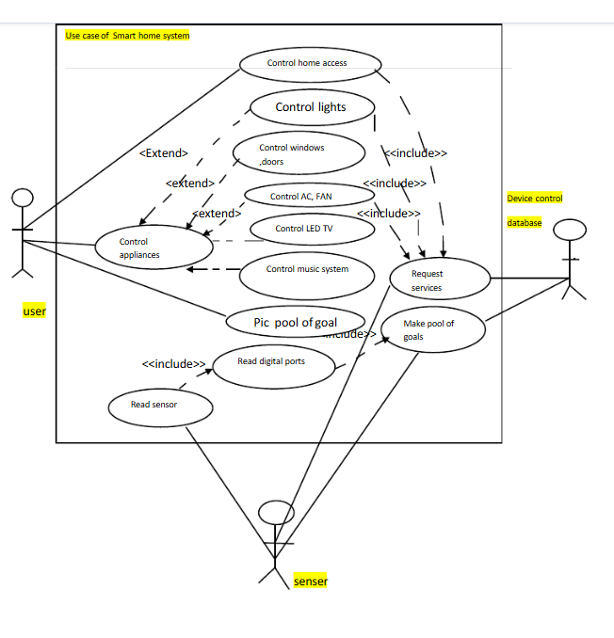

* 1. **Extended use cases**

**3.5.1 Sign up**

|  |  |  |  |  |
| --- | --- | --- | --- | --- |
| **Use Case ID:** | UC 01 | | | |
| **Use Case Name:** | Sign up | | | |
| **Created By:** | Muhammad Ruhaib | | **Last Updated By:** | Afaq Razaq |
| **Date Created:** | 30 December 2023 | | **Last Revision Date:** | 1 January 2024 |
| **Actors:** | | User | | |
| **Description:** | | User will sign up into system with credentials required in the form. | | |
| **Trigger:** | | User will open the website to sign up | | |
| **Preconditions:** | | Following is the precondition   1. User will open the website with Active Internet 2. User does not have any account. | | |
| **Post conditions:** | | Following are the postcondition   1. Customer successfully registers into system. | | |
| **Normal Flow:** | | 1.User navigates to the registration page.  2. User enters required information (name, email, password).  3. User confirms password.  4. User clicks "Register".  5. System confirms registration. | | |
| **Alternative Flows:**  **[Alternative Flow 1 – Not in Network]** | | If passwords do not match, show error message.  If email is already registered, show error message. | | |
| **Exceptions:** | | none | | |
| **Includes:** | | None | | |
| **Frequency of Use:** | | 100 users per day | | |
| **Special Requiremen:** | | Password must meet security criteria. | | |
| **Assumptions:** | | Users should know the English Language. | | |

**Table 6: table of signup use case**

**3.5.2 Login**

|  |  |  |  |  |
| --- | --- | --- | --- | --- |
| **Use Case ID:** | UC 02 | | | |
| **Use Case Name:** | Login | | | |
| **Created By:** | Muhammad Ruhaib | | **Last Updated By:** | Arslan Ahmad |
| **Date Created:** | 30 December 2023 | | **Last Revision Date:** | 1 January 2024 |
| **Actors:** | | User and Admin | | |
| **Description:** | | User logs into the smart home system. | | |
| **Trigger:** | | User opens the login page. | | |
| **Preconditios:** | | 1. User has an active internet connection.  2. User has an existing account. | | |
| **Post conditions:** | | Following are the postcondition   * User successfully logs in and accesses the dashboard. | | |
| **Normal Flow:** | | The normal flow is:   1. User navigates to the login page. 2. User enters email and password. 3. User clicks "Login". 4. System verifies credentials. 5. User is redirected to the dashboard. | | |
| **Alternative Flows:**  **[Alternative Flow 1 – Not in Network]** | | 5a. The alternative flow is start from step 4 of normal flow. If user not enter same password in confirm password field.   1. If User does not have an account then system will show him the message of “Please Register first”. 2. User will click on create new account button. 3. User will create his new account 4. User will enter email and password in login page to continue his normal flow   5b. if user doesn’t make his account   1. The system will show him message “Please register first” 2. User will not make his account 3. Login failed 4. User will be redirected to login page. | | |
| **Exceptions:** | | none | | |
| **Includes:** | | UC 01 : Sign Up | | |
| **Frequency of Use:** | | 100 users per day | | |
| **Special Requirements:** | | In step 3 of the normal flow, if a customer enters credentials (such as email or name) that match another user:  1. The user’s important credentials like password or other secure should not be displayed anywhere in UI. | | |
| **Assumptions:** | | Users should know the English Language. | | |
| **Notes and Issues:** | | 1. The email should be in well format e.g [xyz@gmail.com](mailto:xyz@gmail.com). 2. The password should have at least 1 capital letter, 1 special character and should be at least 8 characters long | | |

**Table 7: table of login use case**

**3.5.3 Control Devices**

|  |  |  |  |  |
| --- | --- | --- | --- | --- |
| **Use Case ID:** | UC 03 | | | |
| **Use Case Name:** | Design Products | | | |
| **Created By:** | Muhammad Ruhaib | | **Last Updated By:** | Arslan Ahmad |
| **Date Created:** | 30 December 2023 | | **Last Revision Date:** | 1 January 2024 |
| **Actors:** | | User | | |
| **Description:** | | User can control smart home devices (lights, thermostat, etc.). | | |
| **Trigger:** | | User accesses the device control panel. | | |
| **Preconditions:** | | User must be logged in. | | |
| **Post conditions:** | | User successfully controls the devices. | | |
| **Normal Flow:** | | The normal flow is:  1.User navigates to the device control panel.  2. User selects a device to control.  3. User adjusts settings (on/off, temperature, etc.).  4. User saves changes. | | |
| **Alternative Flows:**  **[Alternative Flow 1 – Not in Network]** | | The alternative flow will start from 2 of normal flow.  If device is offline, show error message. | | |
| **Exceptions:** | | NULL | | |
| **Includes:** | | UC 02 : Sign Up | | |
| **Frequency of Use:** | | 300 actions per day | | |
| **Special Requirements:** | | Devices must be connected to the network. | | |
| **Assumptions:** | | Users should know the English Language. | | |
| **Notes and Issues:** | | none | | |

**Table 8: table of smart home automation system use case**

**3.5.4 Set Automation**

|  |  |  |  |  |
| --- | --- | --- | --- | --- |
| **Use Case ID:** | UC 04 | | | |
| **Use Case Name:** | Set Automation | | | |
| **Created By:** | Muhammad Ruhaib | | **Last Updated By:** | Arslan Ahmad |
| **Date Created:** | 30 December 2023 | | **Last Revision Date:** | 1 January 2024 |
| **Actors:** | | User | | |
| **Description:** | | User can set automation rules for devices. | | |
| **Trigger:** | | User accesses the automation settings. | | |
| **Preconditions:** | | User must be logged in. | | |
| **Post conditions:** | | Following are the postcondition:   * Automation rules are saved and active. | | |
| **Normal Flow:** | | The normal flow is:  1.User navigates to automation settings.  2. User selects devices to automate.  3. User sets conditions (time, sensor triggers, etc.).  4. User saves automation rules. | | |
| **Alternative Flows:**  **[Alternative Flow 1 – Not in Network]** | | If conditions are invalid, show error message. | | |
| **Exceptions:** | | NULL | | |
| **Includes:** | | UC 02 : Sign Up | | |
| **Frequency of Use:** | | 50 automation per day | | |
| **Special Requirements:** | | Automation must be compatible with devices. | | |
| **Assumptions:** | | Users should know the English Language. | | |
| **Notes and Issues:** | | none | | |

**Data Flow Diagram:**

DFD Level 0

DFD Level 1

**DFD Level 0:**

**System Design:**

A Smart Home Automation System enables users to remotely control and monitor home devices like lights, fans, and security cameras via a mobile app or voice assistants. It consists of smart devices, an IoT gateway for communication, a cloud backend for processing, and a user interface. The system uses MQTT, WebSocket, and REST APIs for device communication, with security features like encryption, OAuth 2.0, and role-based access control. Scalability is ensured through load balancing and edge computing. Integrated with third-party services, it offers a seamless, secure, and efficient home automation experience.

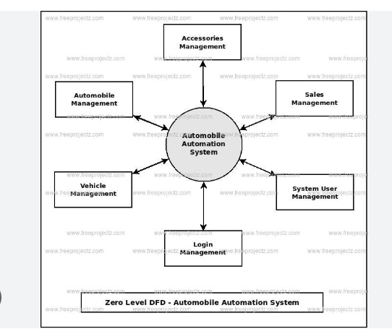

**DFD Level 1:**

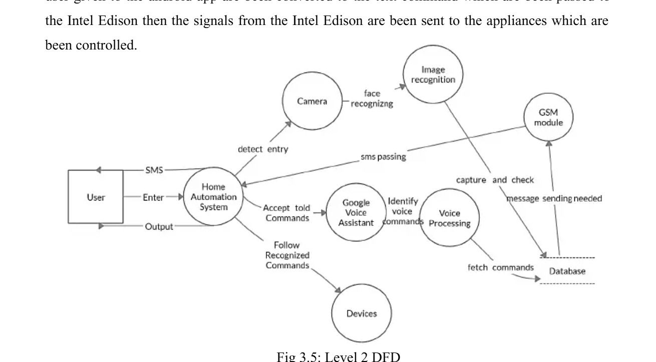

ERD:

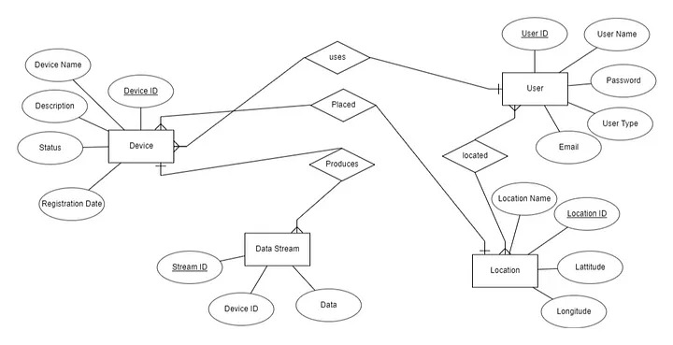

IMPLEMENTATION DETAILS:

**Development Setup**

For developing ths website you need a combination of tools and technologies. Here are some commonly used ones :

**Development Tools**

Visual Studio: The Offical IDE for development of websites. It provides a great environment for coding, debugging and testing.

**Programming Languages:**

**Javascript**: It is used for Client Side (React ), Server Side (Node js) and even for database interactions(for queries). It is the main language used throughout the MERN stack.

**HTML**: It is used within React to define the structure, skeleton and content of the website.

**CSS**: It is used alongside React to design the pages , so that website looks attractive and it can function properly in different devices

**UI\UX tools:**

**Figma**: We have used figma to make the design of our website, Figma is easy to use and more advancing than other tools.

**Debugging:**

Visual Studio Debugger: We have used VSD as it provides breakpoints, step-through code execution, and variable inspection.

**Class Diagram:**

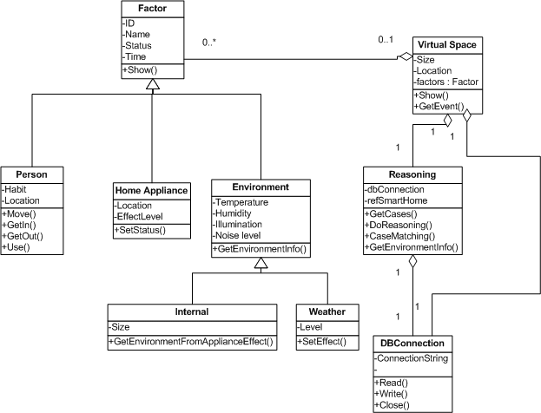

**Sequence Diagram:**

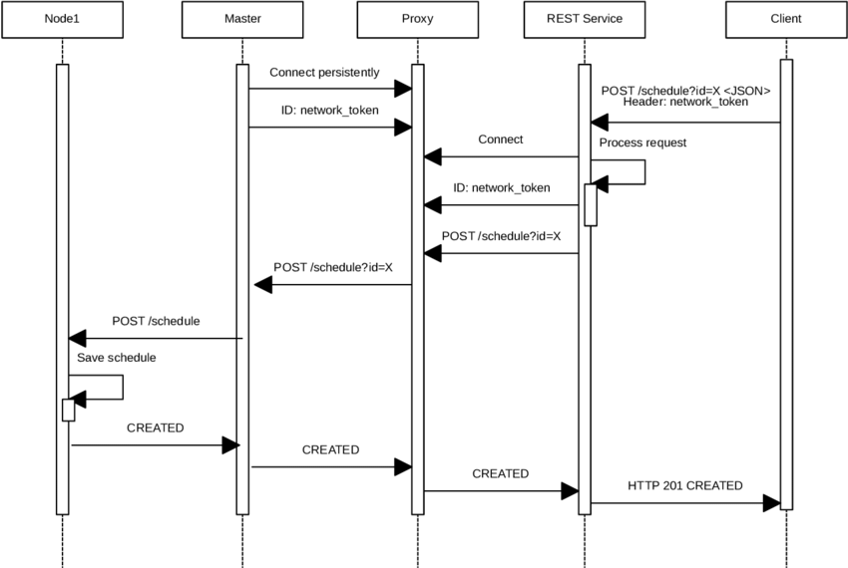

**Testing:**

Testing ensures that the Smart Home Automation System works as intended, is reliable, and meets user requirements. It involves verifying the functionality of various features, such as device control, user interfaces, and system responses.

**Extended Test Cases:**

Extended test cases refer to detailed scenarios designed to test the system under various conditions. For example:

Testing how the system handles multiple devices being controlled simultaneously.

Verifying the system's response to unexpected inputs, such as power outages or network failures.

**Sign Up:**

* This feature allows new users to create an account in the Smart Home Automation System. It involves testing:
* User registration with valid and invalid inputs.
* Secure storage of user credentials.
* Verification processes like email or phone number confirmation.

**Login:**

* The login functionality enables users to access their accounts securely. Testing includes:
* Verifying correct login credentials.
* Handling incorrect passwords or usernames.
* Ensuring secure authentication methods, such as two-factor authentication.

**Design Products:**

* This refers to the ability to customize or configure smart home devices within the system. For example:
* Setting up smart lighting schedules.
* Configuring thermostat preferences. Testing ensures that users can design and save their preferences without errors.

**Cart Functionality:**

* If the system includes an online store for purchasing smart devices, the cart functionality allows users to:
* Add or remove products from the cart.
* Update quantities.
* View the total cost. Testing ensures the cart behaves correctly and integrates with the checkout process.

**Place Order**

* This feature allows users to finalize their purchases. Testing involves:
* Verifying payment processing.
* Ensuring order details are accurate.
* Handling errors during payment or order submission.

**View Order Status**

* This feature lets users track the status of their orders (e.g., "Processing," "Shipped," "Delivered"). Testing ensures:
* Accurate updates on order status.
* Notifications for changes in the order's progress.

**Manage Product**

* This refers to the system's ability to manage smart home devices. For example:
* Adding new devices to the system.
* Removing or updating existing devices. Testing ensures that the system can handle device management seamlessly.

**Manage Order**

* This involves managing orders placed by users. For example:
* Viewing order history.
* Canceling or modifying orders. Testing ensures that users can manage their orders without issues.

**Logout**

* The logout functionality allows users to securely exit their accounts. Testing ensures:
* Sessions are terminated properly.
* No sensitive data remains accessible after logout.

**Traceability Matrix:**

* A traceability matrix is a tool used to ensure that all requirements are covered by test cases and use cases. It helps track the relationship between requirements, use cases, and test cases.

**RID vs UCID (Requirements vs Use Case):**

* This matrix maps Requirements (RID) to Use Cases (UCID) to ensure that every requirement is addressed by at least one use case. For example:
* A requirement like "The system must allow users to control lights remotely" is linked to a use case where the user turns lights on/off via a mobile app.

**PID vs RID:**

* This matrix maps Product IDs (PID) to Requirements (RID) to ensure that every product feature fulfills a specific requirement. For example:
* A smart thermostat (PID) must meet the requirement of "Allow users to set temperature schedules."

**RID vs TID:**

* This matrix maps Requirements (RID) to Test Case IDs (TID) to ensure that every requirement is tested. For example:
* The requirement "The system must send notifications for security breaches" is linked to a test case that verifies the notification system.

<https://www.investopedia.com/terms/s/smart-home.asp>

**Results/Outputs/Statistics:**

This section highlights the measurable outcomes and performance of the Smart Home Automation System. It includes:

**Results:**

* The system's ability to perform its intended functions, such as controlling devices remotely, monitoring energy usage, or enhancing security.
* For example, the system might successfully automate lighting, temperature control, and security cameras.

**Outputs:**

The tangible deliverables, such as a mobile app, a web interface, or a hardware prototype that allows users to interact with the system.

**Statistics:** Quantitative data that supports the system's performance. For instance:

The system achieved a 95% success rate in executing user commands.

Energy consumption was reduced by 20% through automated scheduling.

The average response time for device control was 2 seconds

**Completion**

This section evaluates whether the Smart Home Automation System project was successfully completed. It includes:

**Milestones Achieved:**

For example, the integration of IoT devices, the development of a user-friendly interface, and the implementation of security protocols.

**Timeline Adherence:** Whether the project was completed within the planned schedule.

**Pending Tasks:** Any features or functionalities that were not implemented but could be added in the future, such as AI-based predictive automation or compatibility with additional devices

.

**Accuracy and Correctness**

This section assesses the reliability and functionality of the system:

**Accuracy:**

Refers to how well the system performs its tasks. For example, ensuring that the system correctly turns on the lights or adjusts the thermostat as per user commands.

**Correctness:**

Ensures that the system meets the specified requirements and functions as intended. For instance, the system should only allow authorized users to access and control devices.

Validation:

Includes testing the system under various conditions to ensure it operates reliably and without errors.

**Conclusion**

This section summarizes the overall success and impact of the **Smart Home Automation System:**

**Key Takeaways:**

The system demonstrated the potential to simplify daily life by automating routine tasks, improving energy efficiency, and enhancing home security.

**Lessons Learned:**

Challenges faced during the project, such as integrating multiple devices or ensuring data security, and how they were addressed.

**Future Scope:**

Suggestions for further development, such as incorporating machine learning for predictive automation, expanding compatibility with more devices, or improving security measures to protect user data.

<https://www.sciencedirect.com/topics/computer-science/smart-home-system>

<https://www.academia.edu/3736525/AN_ARTICLE_ON_HOME_AUTOMATION_SYSTEM><http://smarthomes-technology.blogspot.com/p/conclusion-and-additional-work.html>

<https://www.security.org/home-automation/>

<https://circuitdigest.com/home-automation-projects>

<https://www.researchgate.net/publication/347602087_Smart_Home_Automation_System>

<https://www.freeprojectz.com/dfd/automobile-automation-system-dataflow-diagram>

https://www.scribd.com/document/435112106/Device-control-docx